**City Branches Table Exercise**

Consider the following two table’s city and branch table. Write the queries for the same by manually analyzing the tables on how to get the results.

|  |  |  |
| --- | --- | --- |
| **City** |  |  |
| **city_id** | **city_name** | **city_population** |
| 10 | Bangalore | 2367890 |
| 20 | Chennai | 6474836 |
| 30 | Mumbai | 78393739 |

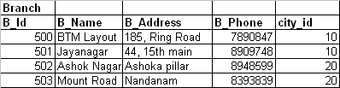

1. Write a query to list the cities which have more population than Bangalore.
2. Display all the branch names from Chennai.
3. Display a city name which does not have any branches
4. Display branch name, address and phone number of all the branches where the name starts with either B or M and the city name starts with either B or C.
5. How many branches we have in Bangalore?
6. Display the branches which are in the Ring road of any city.
7. Display the city name, branch name. Order the data based on the city name.
8. Display the city name and the number of branches in each city.
9. Display the city name which has most number of branches.
10. Display the city name, population, number of branches in each city.